**Tefal Breakfast Maker**

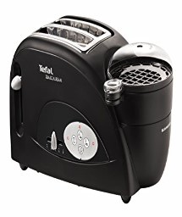

**Key Features  
  
 Brand Warranty  
 220-240v~50Hz.  
 Power: 1300 Watts.  
 With Rotesserie function for grilling full chicken.  
 With kebab/BBQ function for making kebabs, hot dogs, and grilling cubed meat.  
 Ideal for grilling, roasting toasting and baking.  
 Price per Unit: $150/-**

**CORPORATE OFFICE**

    1300 E. Control Tower Rd.  
    Suite 216 Block L3  
    Englewood CO 80112  
 Phone: 720.974.7878  
    Toll Free: 1.877.929.7878  
    Email: [info@choicescreening.com](mailto:info@choicescreening.com)